Welcome to the training section for the Op-Amp Tester Module.  
This module, presented with the signature of Babak Stars, has the capability to test a wide range of op-amp ICs. In the image below, you can see the overall view of the module.

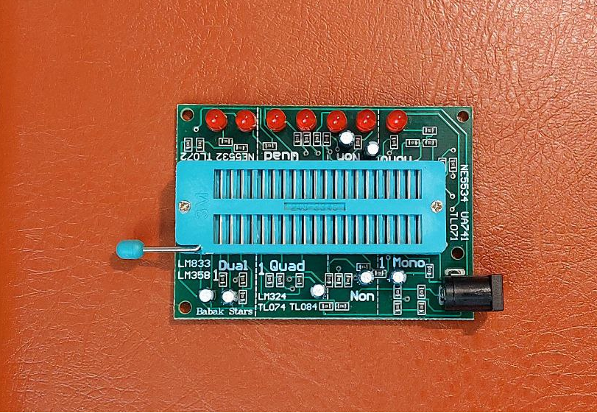

The guides printed on the board are very important. These guides include dashed lines that divide the ZIF socket on the board.

The first section (on the right), called "Mono," is dedicated to testing single op-amps. On this side, the names of several ICs containing single op-amps are printed on the module.

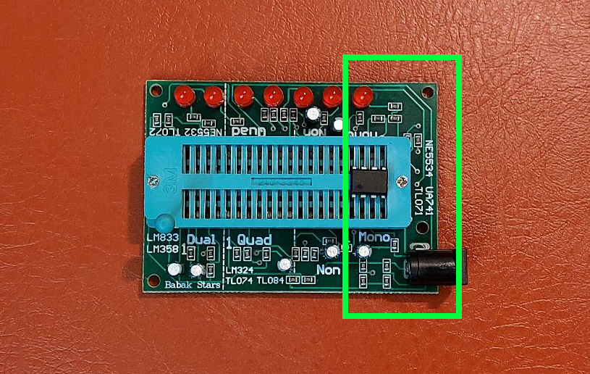

**Important note:** Next to the dashed lines, the number 1 is written to indicate the direction of pin number one of the op-amp IC placed on the ZIF socket.

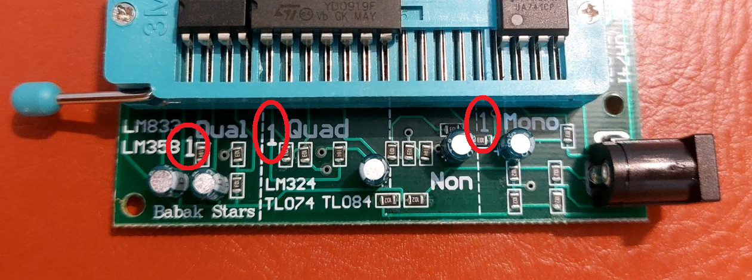

**Important note:** No IC should be placed on the section labeled "Non," because these pins are not used. Please note that using these pins may apply unwanted voltages to your ICs.

|  |  |
| --- | --- |
|  |  |

The middle section is for testing quad op-amp ICs. Some quad ICs are listed on the module.

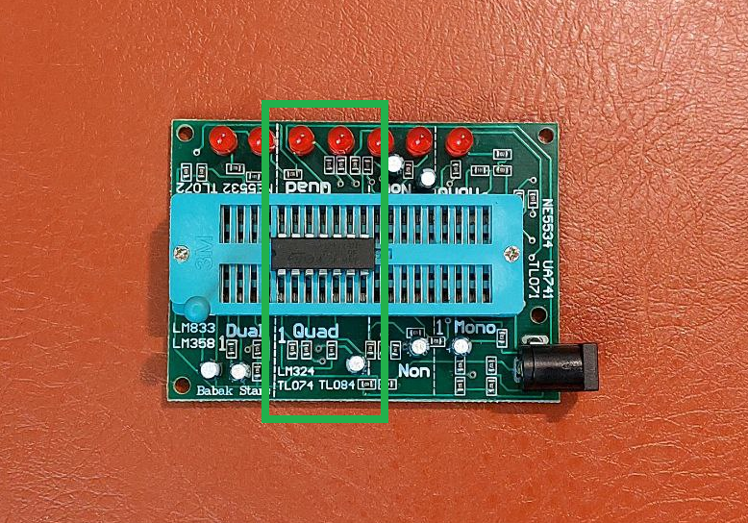

The last section is for dual op-amp ICs. Some dual ICs are listed on the module.

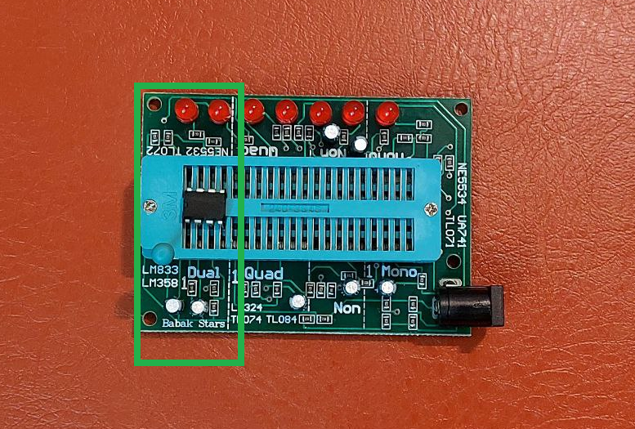

Finally, you can test all three categories of ICs simultaneously. Don’t forget to close the ZIF socket lock after placing the IC, then connect a 12V adapter to the adapter jack.

This module has been tested, and a 12V 1A adapter is highly recommended for working with this module.

